## Milestone 4: Project Code & Report [40 pts] (Due: 5/14/18)

**Peter Victoratos**

**Introduction:**

As a low-budget graphic designer who would one day like to make professional music videos, it can be a very time consuming process to add visual effects to segments of video. Style transfer is a very interesting effect that can be added to videos, but if you don’t have the money to afford a plugin this feat can almost become possible. If there were a way to get this effect in premiere itself would be a pain. This holds especially true if you are trying to have the styles change in rhythm to a song. You would have to apply an overlay filter that changes exactly in line with the spikes in frequency (beat of the kick drum for example). This filter would be difficult to render because there are so many individual frames to render (and you have to find a way to analyze the time for these frequencies).



Thus far, as of 3:09 AM the day its due, I was able to alter some code I found online (along with a great tutorial) to allow me to create gifs of my own images using 3 transfer styles. The number of styles is variable, however I didn’t get too creative with the style images. I ran into an issue where the content images were too big so I tried to avoid using images directly from the internet and stuck to taking screenshots. My target goals were as follows:

* **Low target** - get it to work with your own images and create a gif. Still content image, 3 style images
* **Medium target** - add your separate methods into the main code body, moving content image with 3 style images into a gif
* **High target -** have it analyze the soundwaves of a video and create a movie where the style changes according to a drum beat

I have achieved my low target goals. I have achieved half of my medium target goals. I only have a basic outline of how to make a gif of a stylized moving content image. I then was able to create a wav-file reader that would scan for spikes in the audio signature.

**Method/Discussion of Process:**

1. Get Style Transfer Model Working according to our systems
   1. Download ‘download.py’, ‘vgg16.py’, ‘style_transfer.py’
   2. Select your content and style image, define them in the path variables
   3. Should output the mixed image
2. Configure the model to loop over three styles to create a gif
   1. Create a nested loop to create three mixed images
   2. Create 5 copies of decrementing opacities for each mixed image
   3. Combine all of the copies to make a gif
      1. Image 1 should be displayed at full opacity while Image 2 has 0 opacity. Image 1 goes down a fourth in opacity and image 2 goes up. This keeps going until the other image is added and it wraps around to the first image
3. Configure the model to apply stylzations to a gif/video by splitting its video frames into segments
4. Scan a wav file and assign a style change in time with an audio spike (the beat to a drum)
   1. Can be done with thresholding, finding the relative maxima
   2. Find a way to save the output movie so that the frame changes match up with the music in real time

**Good** **Results:**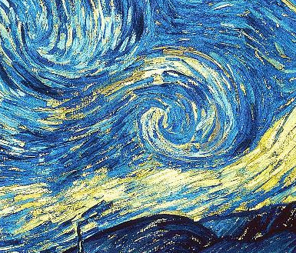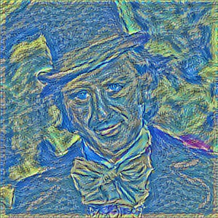

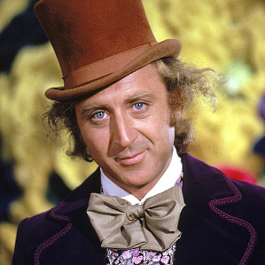

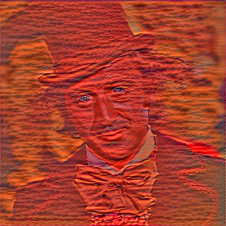

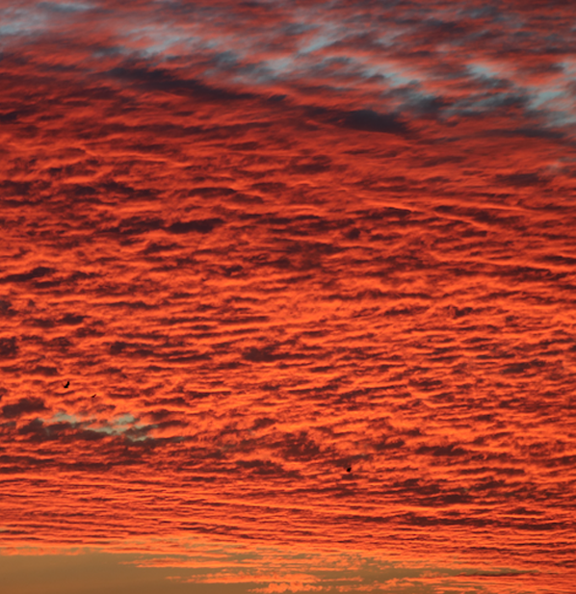

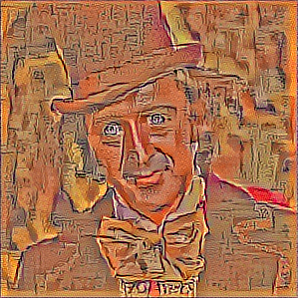

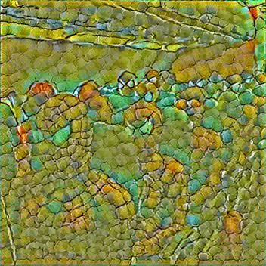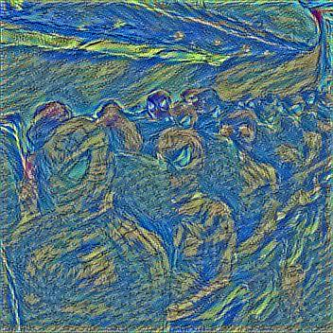

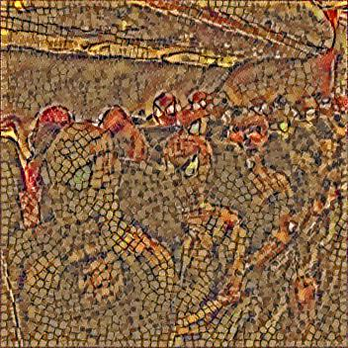

**Poor Result:**

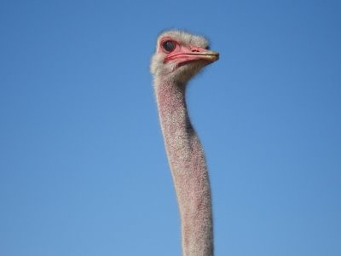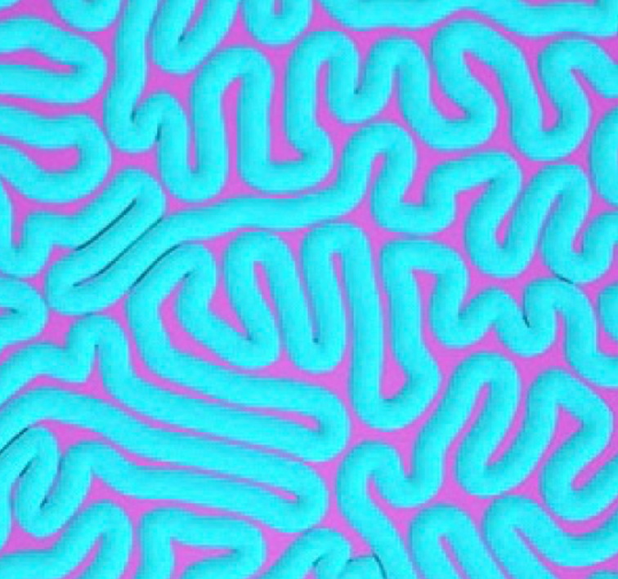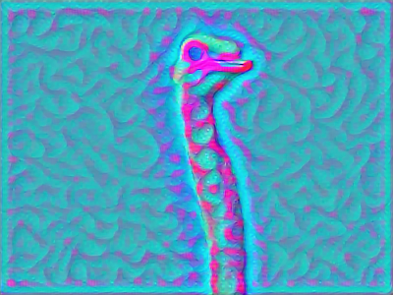

**Conclusions/Discussion:**

It was great to be able to manipulate such a complex model to output a different type of file. My code definitely could have been cleaned up by allocating files to different folders/not even printing them out and just returning the final .gif or .mov file. I also did not write out the part of the code that can make a gif with a moving content image. I had a video of a ball bouncing that I wanted to create a stylized movie out of, aligning the style changes with the ball hitting the ground.

For the future I would have liked to have completed the audio reader. I was able to make a spectrogram of the wav file however I felt short of implementing the data from it. Ideally, I would have been able to take the time signatures at each relative maximum and create a video that changed styles at each frequency spike.

I achieved my medium level goal I’d say. Although I didn’t have the moving gif functional, I felt like the method of approaching it (within the comments) would have worked pretty well. It would have just taken a long time and a lot of memory. I started to tackle the high-level goal but could not get the logic down/a good enough tutorial for scanning .wav files.